**How to Sell Bitcoin**

Selling bitcoin isn't quite as straightforward as buying bitcoin, but fortunately BlogChain is here to help. This guide will give you all the information you need to cash out your digital currency.

When deciding how to sell your bitcoin, you first need to consider which method best suits your situation: **selling** **bitcoin online** or **selling bitcoin in person**. Each option has its own advantages and disadvantages.

**Selling bitcoin online**

Selling bitcoin online is by far the more common way of trading your bitcoin. There are now three ways to go about selling bitcoin online.

*1. The first way involves a direct trade with another person, an intermediary facilitating the connection.*

*2. The second way is through an online exchange, where your trade is with the exchange rather than another individual.*

*3. New peer-to-peer trading marketplaces that allow bitcoin owners to obtain discounted goods with their bitcoin via others that want to obtain the cryptocurrency with credit/debit cards. The two groups are brought together to solve both problems in a kind of peer-to-peer exchange.*

**1. Direct trades**: Websites that offer this type of selling structure include [Coinbase](https://coinde.sk/1KJM4D6" \t "_blank) and [LocalBitcoins](https://coinde.sk/1QlY6Bh" \t "_blank)in the US, and [BitBargain](https://coinde.sk/1MOD1S7" \t "_blank) UK and [Bittylicious](https://coinde.sk/1NI4ulZ" \t "_blank") in the [UK](https://www.coindesk.com/information/buy-bitcoin-uk/).

On these sites, you will usually have to register as a seller. This involves verifying your identity, which we will discuss again later. Once you have registered, you can post an offer, signalling that you want to sell, and the website will alert you when a buyer wants to trade with you. From there, your interaction is solely with the buyer, but you use the website to complete your trade.

The process of selling on [Bitbargain UK](https://coinde.sk/1MOD1S7" \o "Bitbargain" \t "_blank) and (more so) Bittylicious can be quite involved and requires some patience. However, support at the former site has been great in our experience. Bitcoin users with bank accounts in the United States should consider using [Coinbase](https://www.coinbase.com/join/jbonney" \t "_blank) or [Circle](https://www.circle.com/en), which have both won many fans with their simplicity.

[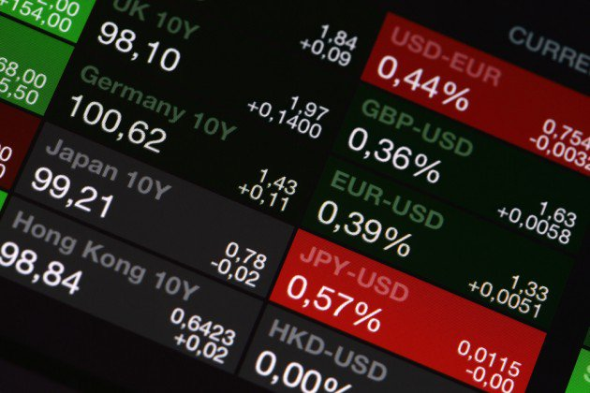](https://media.coindesk.com/uploads/2013/12/shutterstock_123850171.jpg)

**2. Exchange trades**: The other way to sell bitcoins is to register with an online exchange. You will still have to verify your identity, but in this case you won’t have to do as much work when it comes to organizing the sale.

Exchanges act as an intermediary who holds everyone's funds. You place a ‘sell order’ (just as you would place a buy order), stating the volume (amount) and type of currency you wish to sell (eg bitcoin), and the price per unit you wish to sell for.

As soon as someone places a matching buy order, the exchange will complete the transaction. The currency will then be credited to your account.

The downside that accompanies this ease of use is that, if you are selling bitcoin for fiat currencies, you will need to withdraw those funds to your bank. If the exchange is facing liquidity problems or issues with its banks, it can take an inordinate amount of time to receive your funds.

Mt. Gox became infamous for this problem before it [went bankrupt](https://www.coindesk.com/mt-gox-files-bankruptcy-claims-63-6m-debt/), and [BTC-e](https://btc-e.com/) has recently been plagued with reports of similar difficulties. Therefore, you should carefully research the exchange you intend to use before committing funds.

*Examples of other crypto-to-fiat currency exchanges include*[*Circle*](https://www.circle.com/)*,*[*Kraken*](https://www.kraken.com/)*and [Bitstamp](https://www.bitstamp.net/" \t "_blank).*

Alternatively, you could use a pure cryptocurrency exchange to change bitcoin for another cryptocurrency. It's less likely that anyone would want to do this, but there are reasons such as arbitrage, or the rare occasion if a shop accepts something other than bitcoin (for example, [Bitcoin Shop](http://http/www.bitcoinshop.us) now accepts litecoin and dogeoin too, for a wide range of goods).

*Examples of these types of sites are:*[*BTER*](https://coinde.sk/1MX5Eg9)*, [CoinCorner](https://coinde.sk/1LxUlXb" \t "_blank) and [Cryptsy](https://www.cryptsy.com/users/register?refid=324404" \o "Cryptsy" \t "_blank).*

In addition, you’ll have to pay a fee to use some exchanges. BTC-e charges a flat 0.2%. For overviews of what fees are charged by the various cyrptocurrency markets and what volumes are being traded, see [CoinCompare](http://coincompare.com/" \t "_blank) and [Bitcoin Charts](https://www.bitcoincharts.com/markets/) for up-to-date information.

Another consideration is that there will be some limit to the amount of money you are allowed to store (subject to change over time) on an exchange. Regardless, it is not wise to use exchanges to [store your entire pot of coins](https://www.coindesk.com/information/how-to-store-your-bitcoins/), even though it can appear to be the easy option if all you are doing is speculating.

You should take responsibility for your own funds, and store any unneeded amounts on your own devices or offline, rather than trusting an exchange that might one day be hacked.

**3. Peer-to-peer trading marketplaces**

A new development in the bitcoin space is the advent of sites like [Brawker](https://www.coindesk.com/review-brawker-lets-buy-almost-anything-bitcoin/) and [Purse,](https://purse.io/) which set out to bring together two groups of people with specific and complementary needs.

The first group are individuals who want to be able to use bitcoin to buy goods from sites which do not yet directly accept digital currencies. The second comprises of others who would like to buy bitcoin with a credit or debit card. The marketplace brings together individuals with matching requirements to effectively sell bitcoin to one and provide discounted goods for the other.

The marketplace acts as an intermediary, offering users the platform, bitcoin wallet and escrow for transactions.

How it works:

1. Alice posts her required Amazon wish list on the marketplace, stating the discount she would like (normally up to 25%).
2. Bob has a credit/debit card and wants to buy bitcoin matching the value of Alice's purchase(s). He accepts the trade and, through the marketplace, buys the Amazon goods and requests they be delivered to Alice's address.
3. Once the goods are delivered, Alice notifies the marketplace and Bob's bitcoin are released from escrow and arrive in his wallet, minus Alice's agreed discount and a small fee for the marketplace.

This system does mean that Bob will be paying a relatively high fee for the service, but also means he will be easily able to acquire bitcoin via bank card.

**Concerns with withdrawing funds**

The universal way to move money around the world is international wire transfers. Most (if not all) online bitcoin markets support this method of transferral.

[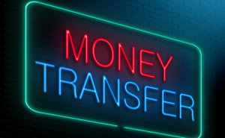](https://media.coindesk.com/uploads/2013/12/shutterstock_158731325.jpg)

Another way to transfer money to your bank after selling bitcoin is via the "Single European Payments Area" ([SEPA](https://en.wikipedia.org/wiki/Single_Euro_Payments_Area)) system. SEPA was designed to make international transfers between member states of the European Union more efficient. Some exchanges (such as Kraken and BTC-e) support these payments.

However, transfers take a very long time (around four days), and can incur large charges – potentially making trading prohibitively expensive. HSBC, for example, charges £4 per SEPA payment made via online banking and £9 per WorldPay transaction. Barclays charges £15 per SEPA payment and £25 for other international transactions.

If you are opening an account with the specific purpose of receiving funds from bitcoin trading, you may find high street banks refuse to do business with you. HSBC has explicitly refused the author of this guide accounts for bitcoin trading.

You can also use third-party payment processors to withdraw and receive fiat funds. The numbers of these services is dwindling, however. [OKPAY](https://bit.ly/1LYH3Dg) recently stopped [engaging with bitcoin businesses](https://www.coindesk.com/okpay-suspends-bitcoin-processing/).

**Identity verification**

[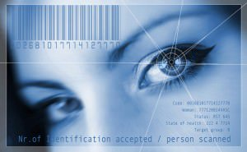](https://media.coindesk.com/uploads/2013/12/shutterstock_2659899.jpg)While many of the bitcoin markets mentioned here require very little identification from buyers, they require a lot of proof of identity from sellers. There are few legal requirements from bitcoin markets to record who their users are, but most (if not all) are preemptively collecting identity data in anticipation of forthcoming regulations.

To make becoming a seller easier, it is worth at least considering completing the identity verification process when you first join the site. Getting this step out of the way can remove barriers to selling if and when you’re ready to make the move.

Expect markets to ask you to upload scans of two utility bills displaying your name and address, along with a photo ID (such as a passport or driving licence). Some (such as BitBargain UK) may even ask you to take a selfie including your photo ID and the name of the market on a piece of paper!

If you are not comfortable uploading such personal documents to an (effectively) untrusted business, then you will have a difficult time finding somewhere to sell bitcoin online.

**2. Selling bitcoin in person**



Selling bitcoin in person can, in many ways, be the easiest way to pass on your digital currency. Simply scanning a QR code on another person's phone and accepting cash-in-hand is about as easy as a bitcoin transaction can get.

If you have friends or family who want to buy bitcoin, the process is simple. Set them up with a bitcoin wallet, send them the bitcoins and collect your cash.

There are several things to be aware of when selling bitcoin in person.

**Agree on a price**: Decide on a rate works for you.

* Many use a price from a prominent bitcoin exchange, or the BlogChain [Bitcoin Price Index](https://www.coindesk.com/price/).
* Some sellers apply a percentage on top of these rates to cover costs and as a convenience/anonymity premium.
* You could use a mobile app to calculate prices. Popular apps include Zeroblock and BTCreport.
* It helps to be aware of local fluctuations in price. Price can vary from country to country, often due to difficulties in obtaining bitcoin with the local national currency.
* There are many bitcoin [meetups](https://www.meetup.com/) around the world where people are happy to trade bitcoin and other cryptocurrencies.

**Stay safe**

* It is always wise when carrying a large amount of cash to meet in a public place and/or go with a friend.

**LocalBitcoins**

* Alternatively, you could advertise yourself as a bitcoin seller to a wider audience. The definitive site for this is [LocalBitcoins](https://localbitcoins.com/?ch=35qy" \t "_blank). This website allows users to rate each other, so one may assess the trustworthiness of a potential trade partner. You may be able to sell with a premium attached once you have a reliable reputation.
* You do not need to verify your identity as on other sites.
* Again, if you are setting yourself up for an in-person meeting using LocalBitcoins, you must always think about the general safety rules for meeting a stranger from the Internet.
* LocalBitcoins also supports escrow transactions, however, these are for online transactions, not face-to-face deals. Therefore, do not comply with requests for someone who asks for escrow for a face-to-face transaction.